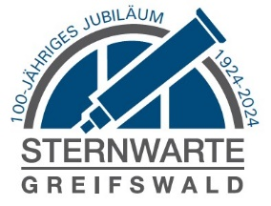

# Johannes Conrads Award

# for Astronomy & Aerospace (2023)

# by Observatory Greifswald e.V.

Abgabetermin ist **Sonntag, der 31. Oktober 2021 um 24:00 Uhr** (Poststempel).

Greifswalder Sternwarte e.V. c/o Dr. Tobias Röwf, Ravensbergweg 2, 14478 Potsdam, sternwarte-greifswald@web.de.

Die Preisträgerin oder der Preisträger erklären sich bereit, im Rahmen der Preisverleihung durch den Greifswalder Sternwarte e.V. namentlich und mit Foto in den Medien an geeigneter Stelle erwähnt zu werden.

Executive Summary

Remarks

Signature

Date

Date of Birth

Name of Supervisor

Name of College / University / Institution

Title of Submitted Work

Email

Telephone

Address

Name of Applicant

Deadline is **Tuesday, October 31, 2023 at 24:00 hours** (Postmark).

Please, submit to Observatory Greifswald e.V.

c/o Dr. Tobias Röwf, President, Ravensbergweg 2, DE-14478 Potsdam, sternwarte-greifswald@web.de.

On the occasion of the award ceremony, the award winner declares s/he is willing to be mentioned with their names and with their (own) photo in the media in a suitable environment. Transfer of ownership: The results of the submitted work can be used for educational purposes to the broad public by the Observatory Greifswald e.V..

Date of Completion